*Name of the Project: Order to Go*

*Restaurants or Fast Food Places can use this application for their clients to order food.*

*This application is allow client to add or remove order, calculate the total cost and display their balance. Each client is required to login.*

*Wireframes:*

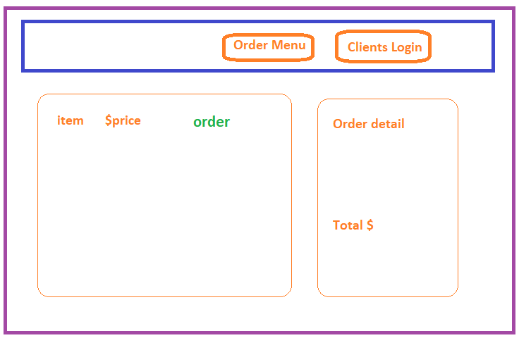

Dependencies: Firebase, react-responsive-carousel, firestore

*Tasks: setup firestore, setup client, setup menu entries*

*3 week plan:*

*1-setup*

*2-coding*

*3-add styles and images*